Visualization Tool for Electric Vehicle Charge and Range Analysis

**Project Description**

A vehicle that can be powered by an electric motor that draws electricity from a battery and is capable of being charged from an external source and have an electric motor instead of an internal combustion engine. The Electric Vehicle (EV) is not new, but it has been receiving significantly more attention in recent years. Advances in both EV analytics and battery technologies have led to increased automotive market share. However, this growth is not attributed to hardware alone. The modern mechatronic vehicle marries electrical storage and propulsion systems with electronic sensors, controls, and actuators, integrated closely with software, secure data transfer, and data analysis, to form a comprehensive transportation solution. Advances in all these areas have contributed to the overall rise of EV’s, but the common thread that runs through all these elements is data analytics. The new EV’s are combined Electrical storage actuators, integrated closely and propulsion systems with electronic sensors, controls, and with software, secure data transfer to form

**Business requirements**

The business requirements for analyzing the performance and efficiency of Electric cars include identifying KPIs, comparing performance across different parameters and brands also, identifying patterns and trends over time, identifying affecting factors, creating interactive dashboards and reports, identifying areas for improvement, making data-driven decisions, comparing to industry average and creating forecasting m odels for future performance. The ultimate goal is to gain insights and improve performance through data visualization techniques

**Dasahboard**

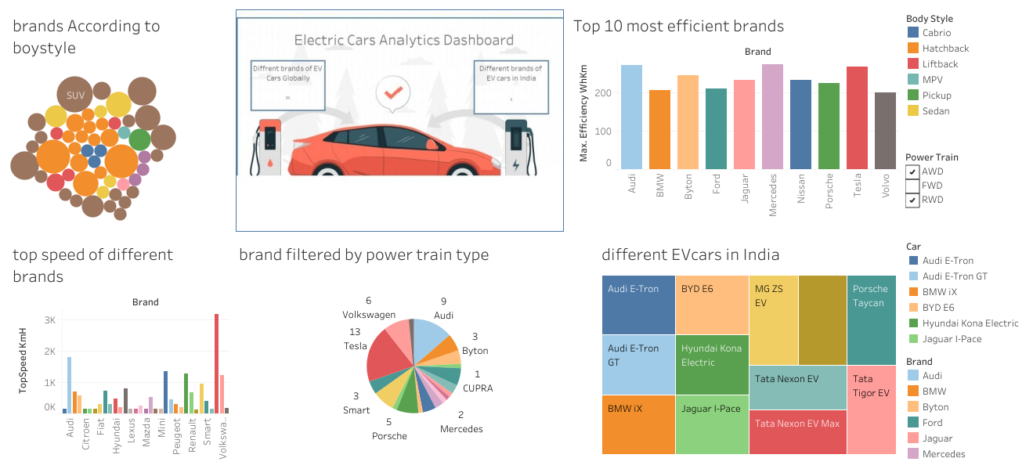

**Visulization tools**

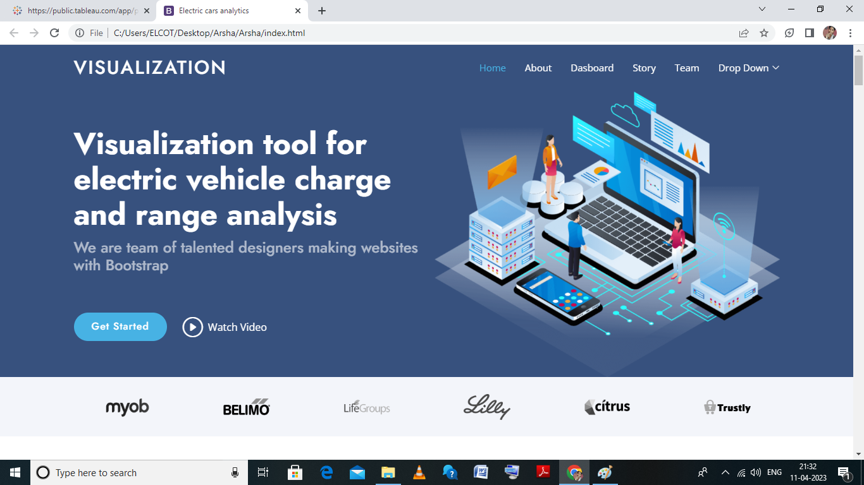

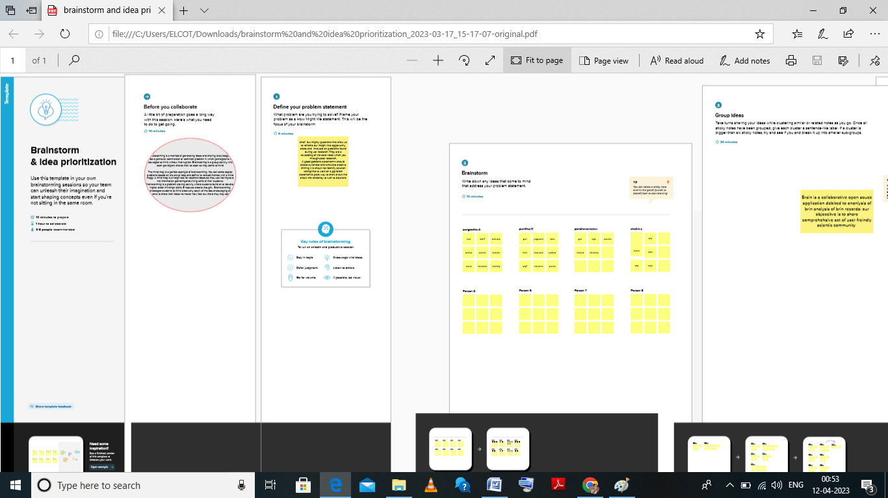



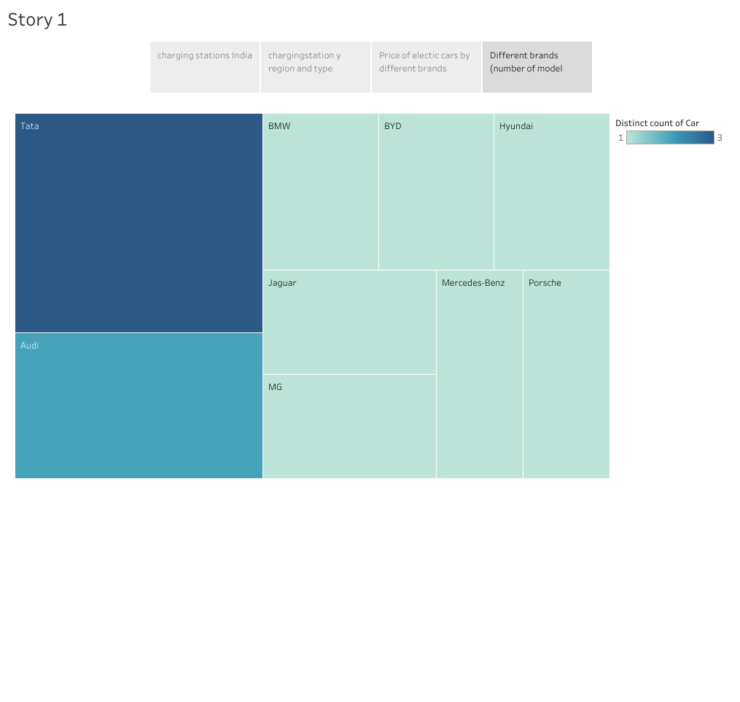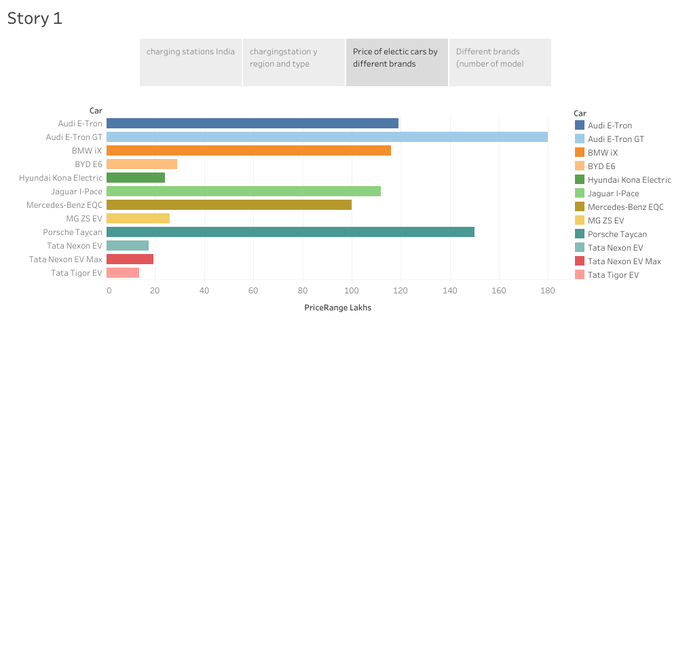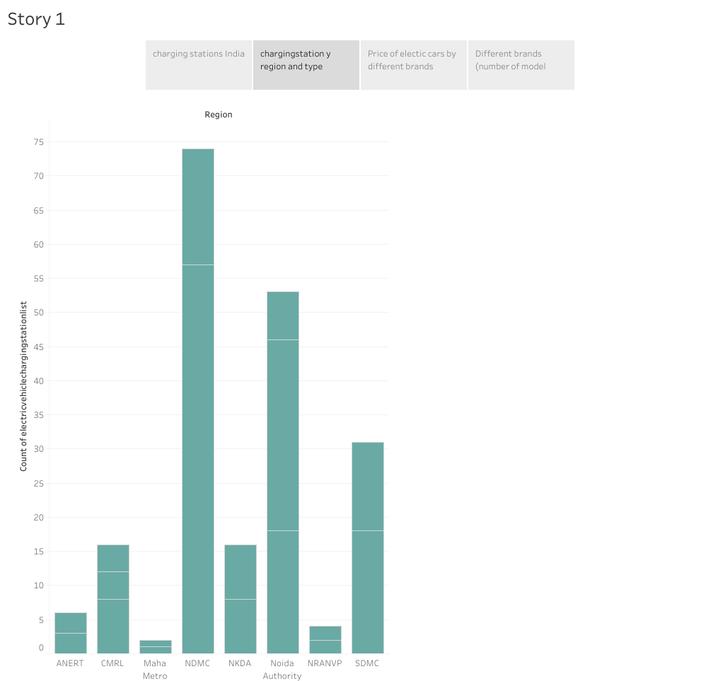**Advantage of visualization**

**Data visualization** is the change of crude information tables into numeric delineations that recount a story. Choosing what data to share, just as how to share it, are the two principal decisions in the making of a viz.

Data visualization can take numerous structures. As a rule, perceptions are diagrams, outlines, plots, and different types of mathematical clarifications. However, depending on it, information representation doesn’t end there. Guides, pictures, and air pocket diagrams are additional sorts of information perception. Any time you see a guide with nations featured for accentuation, you’re taking a gander at an information representation.

Data visualization can take numerous structures. As a rule, perceptions are diagrams, outlines, plots, and different types of mathematical clarifications. However, depending on it, information representation doesn’t end there. Guides, pictures, and air pocket diagrams are additional sorts of information perception. Any time you see a guide with nations featured for accentuation, you’re taking a gander at an information representation.

**Disadvantage of visualization**

Data visualization can take numerous structures. As a rule, perceptions are diagrams, outlines, plots, and different types of mathematical clarifications. However, depending on it, information representation doesn’t end there. Guides, pictures, and air pocket diagrams are additional sorts of information perception. Any time you see a guide with nations featured for accentuation, you’re taking a gander at an information representation.

Data visualization can take numerous structures. As a rule, perceptions are diagrams, outlines, plots, and different types of mathematical clarifications. However, depending on it, information representation doesn’t end there. Guides, pictures, and air pocket diagrams are additional sorts of information perception. Any time you see a guide with nations featured for accentuation, you’re taking a gander at an information representation.

**conclusion**

Unlike interal combustion technology which uses Combusion and pressure to propel to vehicle electric or EV cars are propelledby electromagnetism. These vehicles use electricity typically stored in a battery to power an electric motor.

Application

Electic vehicles use electricity to charge their batteries instead of using fossil fuels like petrol or diesel. Electric vehicles are more efficient, and that combined with the electric vehicle is cheaper than filling petrol or diesel for your travel requirements.